SOLUTION
PROBLEM IN LECTURE NOTES (Session 10 – Slide 48)

Re. 1 |  | Re. 2 |  | Re. 3 |  | Re. 4
B1 | B2 | B1 | B2 | B1 | B2 | B1 | B2
(1) = -3  ac = 2  ab = 2  bc = 1 | abc = 6  a = 0  b = -1  c = -1 | (1) = -1  ac = 1  ab = 3  bc = 1 | abc = 5  a = 1  b = 0  c = 0 | (1) = -2  ac = 2  ab = 2  bc = 2 | abc = 4  a = 1  b = -1  c = 1 | (1) = -3  ac = 1  ab = 3  bc = 2 | abc = 4  a = 0  b = 0  c = 1

1. 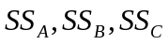
Note that (1) = -9 a = 2 b = -2 ab = 10
c = 1 ac = 6 bc = 6 abc = 19
Using the contrast, we have: 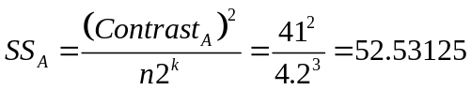

Similarly, 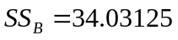 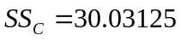

2. 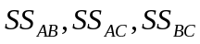
Using the contrast, we have 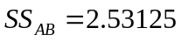 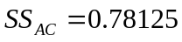 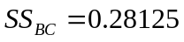

3. 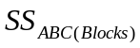
Using the contrast of ABC: 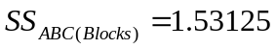

4. 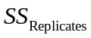
We have: 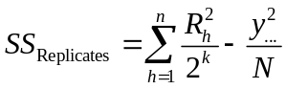
Note that: 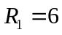 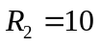 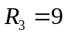 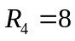
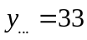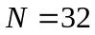

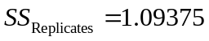

5. 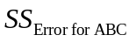 or 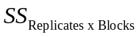 (be careful!)

 | Re. 1 | Re. 2 | Re. 3 | Re. 4 | 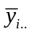
Block 1 | 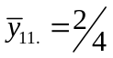 | 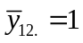 | 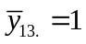 | 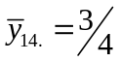 | 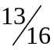
Block 2 | 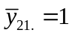 | 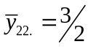 | 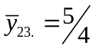 | 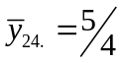 | 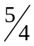
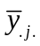 | 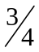 |  | 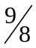 |  | 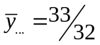

So, 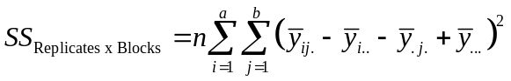 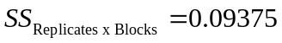
6. 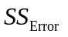 or 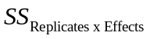 (be careful!)

a. 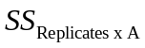:

 | Re. 1 | Re. 2 | Re. 3 | Re. 4
A+ | a ab  ac abc | a ab  ac abc | a ab  ac abc | a ab  ac abc
A- | (1) b  c bc | (1) b  c bc | (1) b  c bc | (1) b  c bc

 | Re. 1 | Re. 2 | Re. 3 | Re. 4
A+ | 0 2  2 6 | 1 3  1 5 | 1 2  2 4 | 0 3  1 4 | 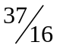
A- | -3 -1  -1 1 | -1 0  0 1 | -2 -1  1 2 | -3 0  1 2 | 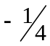

So, 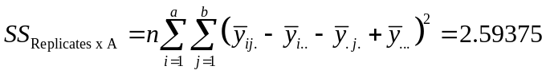

b. Similarly, 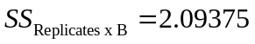 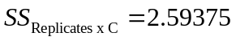

c. 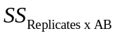:

 | Re. 1 | Re. 2 | Re. 3 | Re. 4
(AB)+ | (1) ab  c abc | (1) ab  c abc | (1) ab  c abc | (1) ab  c abc
(AB)- | a b  ac bc | a b  ac bc | a b  ac bc | a b  ac bc

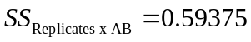

d. Similarly, 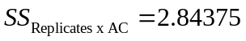 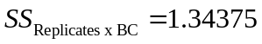

Hence,
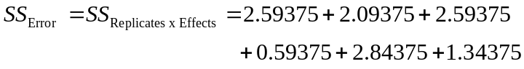

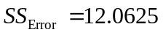
Actually, this can be computed indirectly by first computing 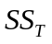 then subtracting all other sums of squares from
SUMMARY

Source of Variation | SS | d.f.
Replicates | 1.09375 | 3
Block (ABC) | 1.53125 | 1
Error for ABC (Replicates x Blocks) | 0.09375 | 3
A | 52.53125 | 1
B | 34.03125 | 1
C | 30.03125 | 1
AB | 2.53125 | 1
AC | 0.78125 | 1
BC | 0.28125 | 1
Error (Replicates x Effects) | 12.0625 | 18
Total | 134.96875 | 31
(Note that total sum of squares can be computed directly)

From the above values, ANOVA analysis can be conducted to determine significant effects.

